61.

**Right from the start** there was trouble with the Hubble. （从最开始哈勃望远镜就有问题）

·from the start表示“从开始时”，副词right起强调作用。

The pictures it sent us were very disappointing because its main mirror was **faulty**!

·faulty adj.有缺陷的, 不合格的, 有错误的。

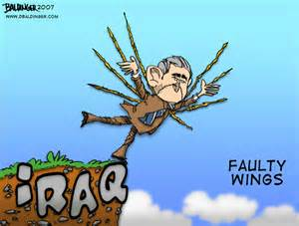

NASA is now going to put the telescope right, so it will soon be **sending up** four **astronauts** to repair it. （国家航天局准备纠正这一错误，为此将把4名宇航员送入太空修复望远镜）

·astronaut ['æstrə.nɔ:t] n. 宇航员。



**The shuttle Endeavour** will be taking the astronauts to the Hubble. （“奋进”号航天飞机将把宇航员送上哈勃）

·shuttle ['ʃʌtəl] n. 航天飞机。**space shuttle 航天飞机，太空船。**

·Endeavour [in'devə] n. 尽力，努力；“奋进”号。

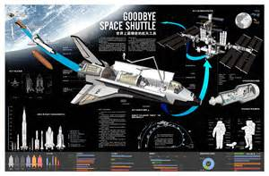



it will soon be sending us the clearest pictures of the stars and **distant galaxies** that we have ever seen. （它很快就会给我们传送我们所见到过的、有关行星和**远距离星系**的最清晰的照片）

·distant adj. 遥远的。

·galaxy ['gælə-ksi] n. 星系。



**By the time** you read this, the Hubble's **eagle eye** will…（等到你读到这篇文章时，敏锐的哈勃望远镜…）

·eagle ['i:gəl] eye 鹰眼、“锐利目光”。



62.

**great trees** had covered the countryside **for miles around**. （**参天大树**还覆盖着方圆数英里的土地）

·**for miles around,方圆数英里。**

Now, smoke still rose up from the warm ground over the **desolate hills**. （而现在，发热的地面上仍然升腾着烟雾，弥漫在荒凉的山丘上）

·desolate ['desəl.eit,'desəlit] adj. 荒凉的。

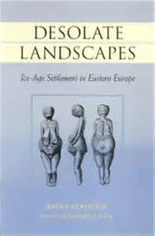

**Winter was coming on** and the hills **threatened** the surrounding villages **with** **destruction**, （冬季即将来临，这些山丘对周围的村庄具有毁灭性的威胁，）

·**come on**的**“过去进行时”形式表示的是“过去将来时”**，它在这里**表示季节的“到来”、“来临”**。

·threaten ['θretn] v. 威胁。

·destruction [di'strʌkʃən] n. 破坏，毁灭。

·**threaten…with表示“以…威胁/恐吓…”。**The thief **threatened** him **with** a knife.小偷用刀子威胁他。



for heavy rain would **not only** wash away the soil **but** would cause **serious floods** **as well**. （因为大雨不仅会冲走土壤，而且还会引起**严重的水灾**）

·与并列连词 **not only…but(also)**的含义一样，**not only…but…as well**也**表示“不仅……而且……”**，用于连接并列句，只是as well通常位于句尾。

the forest **authorities** ordered several tons of a special type of grass-seed which would grow quickly. （森林管理当局订购了好几吨一种生长迅速的特殊类型的草籽）

·autho-rity [ə'θɔ-rəti] n. （常用复数）当局。

·grass-seed n. 草籽。



The seed was **sprayed over the ground** in huge quantities by aeroplanes. （飞机把这种草籽大量地撒播在地上）

·spray [sprei] v. 喷撒。

·quantity n. 量。**in huge quantities,大量地。**



The planes had been **planting seed** for nearly a month when it began to rain. （飞机撒播近一个月后，开始下起雨来）

·plant [plænt]v.**种植**, 设立, 建立, 安插, 栽赃。

By then, however, in many places the grass had already **taken root**. （然而到那时，很多地方的草已经生了根）

·**take root表示“生根”。**

**In place of** the **great trees** which had been growing there for centuries **patches of green** had begun to appear in the **blackened soil**. （**一片片的绿草**开始出现在这片烧焦的土地上，代替了多少世纪以来一直生长在那里的参天大树）

·**in place of表示“代替”、“取代”。**

·patch n. 小片。patch的含义之一是“颜色和周围不同的部分”。 There are **patches of cloud** in the sky. 天空中有**片片白云**。

·blacken v. 变黑，发暗。blackened为过去分词，作形容词用，表示“变黑了的”、“**烧焦的**”。

63.

Jeremy Hampden **has a large circle of friends** and is very popular at parties. （杰里米.汉普登**交际甚广**，是各种聚会上深受大家欢迎的人）

·popular在这里表示“受欢迎的”、“得人心的”。

Everybody admires him for his **great sense of humour** （人人都钦佩他那绝妙的幽默感）

·admire v. 赞美，钦佩。

·**sense of humour指“幽默感”。**



Recently, one of Jeremy's closest friends asked him to **make a speech** at a **wedding reception**. This is the sort of thing that Jeremy loves. （最近，杰里米的一个最亲密的朋友请他在一个婚礼上祝词。这正是杰里米喜欢做的事情。）

·reception n. **招待会**。**wedding reception n. 婚宴，（婚礼后）结婚茶会**



He prepared the speech carefully and went to the wedding with Jenny.（他认真准备了讲稿，带着珍妮一道去参加了婚礼）

Jeremy was a little disappointed by this but he did **as** his daughter asked. （这不免使杰里米有点扫兴，但他还是按照女儿的要求做了）

·**as引导的是方式状语从句，**其含义为“**如同……那样**”、“以……的方式”。 This fish isn't cooked **as** I like it. 这条鱼不是按我喜欢的那样做的。

Jeremy asked her **why this was so** and she told him that she did not like to see so many people laughing at him!（杰里米问他为何不喜欢，她说她不愿意看到那么多的人嘲笑他！）

·this was so代指前面提到的情况，即she hadn't enjoyed the speech, this指“上述之事”，**so表示“如此的”**。

64.

**The Channel Tunnel（海峡隧道）**

tunnel n. 隧道。

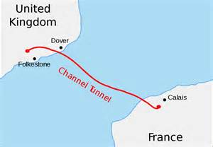

a French engineer, arrived in England with **a plan for** a twenty-one-mile tunnel under the English Channel. （一位名叫埃梅.托梅.德.干蒙的法国工程师带着建造一条长21英里、穿越英吉利海陕的隧道计划到了英国）

·**plan for +名词／动名词：表示“……的计划”。**

He said that **it would be possible to** build a platform in the centre of the Channel.（他说，可以在隧道中央建造一座平台）

the tunnel would be **well-ventilated** if tall **chimneys** were built above sea level. （如果再建些伸出海面的高大的烟囱状通风管，隧道就具备了良好的通风条件）

·ven-ti-lation [.ven-tə-l'ei-ʃən] n. 通风。

·chimney n. 烟囱。

·**sea level 海平面。**

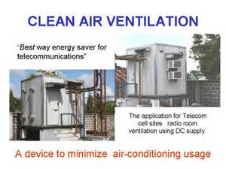

a better plan was **put forward** by an Englishman, （一位名叫威廉.洛的英国人提出了一项更好的计划）

·**put forward**为固定短语，可分开用，其含义之一是“**提出（计划、建议等）**”。

This would solve the problem of **ventilation**, for if a train entered this tunnel, it would **draw in** fresh air behind it. （这样就解决了通风问题。因为如果有列火车开进隧道，它就把新鲜空气随之抽进了隧道）

·**draw in 吸引，拉入**。

**1.PHRASAL VERB（白昼）渐短；（天黑）渐早**If you say that the nights, evenings, or days are drawing in, you mean that it is becoming dark at an earlier time in the evening, because autumn or winter is approaching.

The days **draw in** / and the mornings get darker. （**白天的时间越来越短**）天黑得越来越早，天亮得越来越晚。

**2.PHRASAL VERB使参与；使卷入**If you draw someone in or draw them into something you are involved with, you cause them to become involved with it.

It won't be easy for you to **draw him in**... 你要**让他参与进来**可不容易。

You gradually fall under the spell / and **get drawn in [**deeper and deeper]... 你会渐渐着魔，**越陷越深。**（**spell** [spel] **n. 符咒，咒语**。）

Don't let him **draw you into** his strategy. 不要让他**把你卷进**他的行动计划。

**3.PHRASAL VERB深呼吸；吸入（空气）**If you draw in your breath, you breathe in deeply. If you draw in air, you take it into your lungs as you breathe in.

Rose **drew** her breath **in** sharply... 罗丝**猛**地**吸**了口气。

Roll the wine around in your mouth, **drawing in air** at the same time. 让酒在嘴里滚一下，同时**吸气**。

If, at the time, the British had **not feared invasion**, it would have been completed. （如果不是因为那时英国人害怕入侵，隧道早已建成了）

·fear v. 害怕。

·invasion [in'veiʒən] n. 入侵，侵略。



It was **officially** **opened** on March 7,1994, finally connecting Britain to **the European continent**. （它于1994年3月7日正式开通，将英国与欧洲大陆连到了一起）

·officially adv. 正式地。

·continent [‘kɔntinənt] n. 大陆。

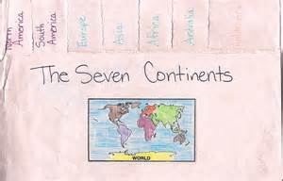

65.

Jumbo **versus** the police（小象对警察 ）

·versus ['və:səs] prep. 对抗, 与…相对(略作v.或vs.)。versus表了竞赛等中“…对…”

the **circus** owner, Jimmy Gates, decided to take some presents to a children's hospital. （马戏团老板吉米.盖茨决定送些礼物给儿童医院）

·circus ['sə:kəs] **n.马戏团, 马戏表演**。

·honour ['ɔnə] n.荣誉, 头衔, 荣幸。

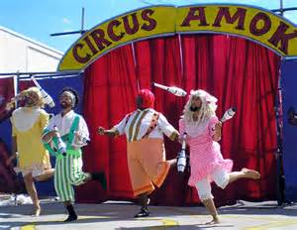

**Dressed up as** Father Christmas and **accompanied** by a '**guard of honour**' of six pretty girls,（他打扮成圣诞老人，在由6个漂亮姑娘组成的“仪仗队”的陪同下）

·**dress up as表示“装扮成…（的样子）”**，这里的 dressed 有表示状态的含义。

·在英国英语中，**圣诞老人**通常用 **Father Christmas**表示。Father大写可表示对老人的一种尊称：Father Baker（贝克大爷／老爹）。

·accompany [ə'kʌmpəni] vt.**陪伴,随行**；伴随…发生。

·**guard of honour指“仪仗队”。guard可表示“（一队）警卫队”、“（一队）卫兵／哨兵”等**。

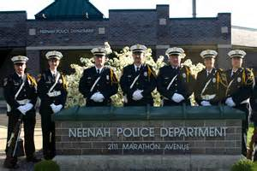

he set off **down the main street** of the city riding a baby elephant called Jumbo. （骑上一头名叫江伯的小象，沿着城里的主要街道出发了）

·down在这里是介词，表示“**沿”、“顺”、“循**”的意思。

**He should have known** that the police would never allow this sort of thing. （他本该知道警察绝不会允许这类事情发生）

A policeman **approached** Jimmy and told him he ought to have gone along a side street as Jumbo was **holding up the traffic**. （一个警察走过来告诉吉米，他应该走一条小路，因为江泊**阻碍了交通**）

·approach [ə'prəutʃ] v.靠近, 接近。

·**hold up**其含义之一为**“阻止”、“使停顿”、“延误”、“阻碍”**。

PHRASAL VERB**耽搁；阻延**To hold up a person or process means to make them late or delay them.→see usage note at:cancel

Why were you **holding everyone up**?... 你为什么**耽搁了大家**？

Continuing violence could **hold up** progress towards reform. 持续的暴力活动，可能会**阻延**改革的进程。



Fifteen policemen had to push very hard to **get** him **off** the main street. （15个警察不得不用很大的力气把它推离主要街道）

·**get off**在这里表示“**从……移去／除去**”。

so it was **fortunate** that we didn't have to carry him. （值得庆幸的是它没让我们抬它走）

·fortunate ['fɔ:tʃənit] adj.幸运的, 侥幸的。

66.

Wallis Island, **a remote place** in the South Pacific,（那是南太洋中一个很**偏僻的**小岛）

·remote adj. 偏僻的。

but **over the years**, the crash was forgotten and **the wreck** remained undisturbed. （这起飞机失事已被遗忘，飞机残骸也没受到破坏）

·**over the years, 多年来。**over 表示“在……期间／之中”。

·wreck [rek] n. 残骸。

·un-dis-tur-bed [ʌn-di's-tə:bd] adj.未受干扰的, 安静的, 镇定的。

the plane was **accidentally rediscovered** in an **aerial survey** of the island. （飞机失事26年后，在对小岛的一次**航空勘查**中那架飞机被**意外地发现**了）

·accidentally adv.偶然地, 意外地, 附带地。

·aerial adj. 航空的。

·**survey** [sə'vei] **n. 调查**。



By this time, a Lancaster bomber **in reasonable condition** was rare and worth rescuing. （到了那个时候，状况良好的兰开斯特轰炸机实属罕见，值得抢救）

·reasonable adj. **reasonable在这里表示“尚好的”、“过得去的”**，用于表示价钱时，它指“公道的”、“合理的”、“不贵的”等。

·rescue ['reskju:] v. 营救。

The French authorities **had the plane packaged and moved** in parts back to France. （法国政府让人把飞机包装起来，一部分一部分地搬回法国）

·package v. 把……打包。

句中 **have为使役动词，表示“使”，**后面+名词／代词+过去分词。packaged和 moved 都属于这种结构。Have something done 让别人做某事。

·**in parts** : little by little ,bit by bit **一部分一部分地。**

Now a group of enthusiasts are going to **have the plane restored**. （一群热心人计划修复这架飞机）

·**enthusiast** [in'θju:zi.æst] n. **热心人；热衷于……的人**。《wine enthusiast》 《葡萄酒爱好者》。

·restore v. **修复**。

but the group will need to **have** only three of **them rebuilt**.（但是他们只需要修复其中的3台）



Imagine their surprise and delight when they **broke open** the **packing cases** and found that the fourth engine was sweet as honey -- still in perfect condition. （想一想他们所感受到的惊奇和兴奋 —— 当他们拆开包装箱时，他们发现第4台发动机就像蜂蜜一样甜 —— 发动机完好无损）

·delight n.v. 高兴, 快乐。

·**broke open v. 撬开(拆开, 破开)。**break sth open 打开。tear it open 撕开（信封）

·**packing case n. 包装箱，**装运货物的箱子。

**A colony of bees** had **turned** the engine **into** a **hive** and it was totally preserved in **beeswax**! （一群蜜蜂把发动机当作了蜂房，发动机在蜂蜡中被完整地保存了下来）

·colony ['kɔləni] n. 群。

·hive n. 蜂房。

·**turn into表示“把……改变成……”**。

·preserve v. 保护。

·beeswax n. 蜂蜡。





67.

the Polish scientist, has spent his lifetime studying **active volcanoes** and **deep caves** in all parts of the world. （波兰科学家哈罗恩.塔捷耶夫花了毕生的精力来研究世界各地的**活火山**和**深洞**）

·active adj. 活动的。

·volcano n. 火山。



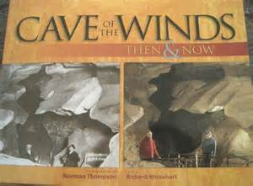

he went to Lake Kivu in the Congo to **observe** a new volcano which he later named Kituro. （他去了刚果的基伍湖，对一座后来被他命名为基图罗的新火山进行观察）

·observe [əb'zə:v] v.**观察**,注意到。



Tazieff was able to **set up his camp** very close to the volcano while it was **erupting violently**. （当火山正在**猛烈地喷发**时，塔捷耶夫有办法把帐篷搭在离它非常近的地方）

·erupt v. （火山）喷发。

·violently adv. 猛烈地，剧烈地。

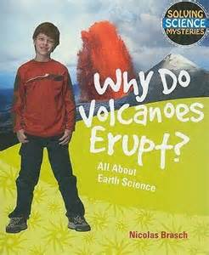



Though he managed to take a number of **brilliant photographs**, （尽管他设法拍了一些十分精彩的照片，）

·brilliant adj. 精彩的。



He noticed that **a river of liquid rock** was coming towards him.（他发现有一股岩浆正向他流过来，）

·liquid adj. 液态的。

·**a river of liquid rock,一股岩浆。**river在这里为比喻用法，表示“（……的）巨流”。由于 a river of 这个结构中没有 as, like等明确表示“像”的词，因此，它是一种暗喻。

When she heard the news, **a river of tears** came down her face.她听到这个消息后，泪如泉涌。

It **threatened to** surround him completely, but Tazieff managed to escape just in time. （眼看就要将他团团围住，但塔捷耶夫还是设法及时逃离了）

·threaten表示“威胁着要”、“恐吓”。 He threatened to leave the team. 他扬言要离开这个队。

he managed to climb into **the mouth of Kituro** so that he could take photographs and **measure temperatures**. （这次他设法爬进了**基图罗火山口**，以便能拍摄照片和测试温度）

·measure v.测量, 比较。

Tazieff has often **risked his life** in this way. （塔捷耶夫经常冒这样的生命危险）

·**risked one's life, 冒着生命危险。**

**6**8.

I crossed the street to **avoid meeting him**, （我穿过马路以便避开他）

·avoid v. 避开。**avoid doing sth.** avoid 以及本课中出现的 enjoy, fancy, mind, finish等动词后面只跟名词性的宾语，即只跟名词或动名词。

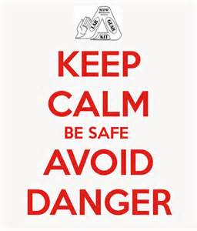

**It was no use** pretend**ing** that I had not seen him,（若再装作没看见他已是没有用了，）

·**It is (of) no use doing…（其中的 of可省略），表示“做……也是徒劳的／无益的”** It is (of) no use worrying about your family.为你的家人担心是无益的。

He never has anything to do. **No matter how busy you are**, he always **insists on** com**ing** with you. （他从来都是无事可做，不管你多忙，他总是坚持要跟你去）

·insist v. 坚持做。**insist on doing sth.** 如：

Life is really simple,but we **insist on** mak**ing** it complicated. 生活很简单，但我们却总是把它弄得很复杂



I had to **think of a way** of **preventing him from following me** around all morning. （我得想办法不让他整个上午缠着我）

·**think of**在这里的含义是“**想出**”。

·prevent表示“**阻止／制止**”时其常用结构为 **prevent sb. from doing sth.**

Persistent（纠缠不休）

·persistent [pə'sistənt] adj. 坚持的，固执的。

persist:坚持（不顾阻拦一味的坚持）**persist in doing sth.**

insist:坚持（认为、说、是人的一种态度） **insist on doing sth.**

**'Fancy meeting you here!**' （**想不到在这儿见到你**）

·Fancy n. 设想，想像。喜爱, 幻想, 想像力。**fancy ball** n.**化装舞会**

You're not busy doing anything, are you?' （你不忙，是吗？）

69.

I was being tested for a **driving licence** for the third time. （我第3次接受驾**驶执照考试**）

·licence ['laisəns] n.执照, 许可, 特许, 自由, 放纵。



I had been asked to drive in **heavy traffic** and had done so successfully. （按照要求在车辆拥挤的路上驾驶，我圆满地完成了）

·heavy在这里表示“大量的”、“多的”、“密集的”。

After having been **instructed** to drive out of town, I began to **acquire confidence**. （在接到把车开出城的指令后，我开始**有了信心**）

·instruct v. 命令，指示。

·acquire v. 取得，获得。acquire通常表示通过努力“获得”、“学到（知识、技术、语言等）”，也可用来表示“养成（习惯等）”。Tom **acquired a habit of** smoking.汤姆养成了抽烟的习惯。

·confidence n. 信心。



The examiner must have **been pleased with** my performance, （主考人对我的驾驶想必是**满意**的）

·examiner n. 主考人。

·please v.使高兴, 使满意。

As soon as I **tap on the window**, you must **stop within five feet.**' （我一敲车窗，你必须把车**停在5英尺之内**）

·tap v. 轻敲。

·within **prep**不超过，在…的范围内。在…内，在…里面。

it took me a long time to **react**. （我过了好一会儿才作出反应）

·react v. 反应。

I suddenly **pressed the brake pedal** and we were both **thrown forward**. （我突然用力**踩紧刹车踏板**，结果我俩的身体都**向前冲去**）

·brake n. 刹车。

·pedal n. 踏板。

·throw v.扔, 投, 掷, 抛。



he said, **in a mournful voice**, （主考人伤心地看着我）

·mournful adj. 悲哀的。

·**in a… voice 表示“以……的声调”**。



70.

During a **bullfight**, a **drunk** suddenly **wandered** into the middle of the **ring**. （在一次斗牛时，一个醉汉突然溜达到斗牛场中间）

·**bullfight n. 斗牛**。

·drunk n. 醉汉。

·**wander v. 溜达，乱走。**

·ring n. 圆形竞技场地。

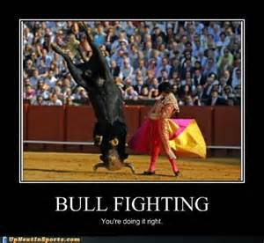

The **bull** was busy with the **matador** at the time, （当时那公牛正忙于对付斗牛士，）

·bull n. 公牛。

·**matador** ['mætədəur] **n. 斗牛士**。

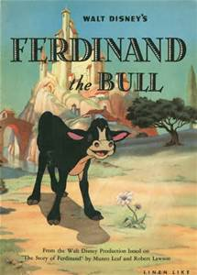



but it suddenly **caught sight of** the drunk who was shouting **rude remarks** and waving a red cap. （但突然它看见了醉汉，只见他正大声说着粗鲁的话，手里挥动着一顶红帽子）

·**catch sight of**是个固定短语，意为**“看见”、“发现”**。

·**remark n. 评论；言语**。

Apparently **sensitive to criticism**, the bull forgot all about the matador and **charged at** the drunk. （对挑衅显然非常敏感的公牛完全撇开斗牛士，直奔醉汉而来）

·apparently adv. 明显地。

·**sensitive ['sensətiv] adj. 敏感的。**sensitive表示“敏感的”、“神经过敏的”、“易生气的”或“介意的”等，通常与to+名词连用，也可作定语Mary is sensitive to smells.玛丽对气味很敏感。

·**criticism ['kritə.sizəm] n. 批评。sensitive to criticism,对挑衅／批评敏感。**

·**charge v. 冲上去**。

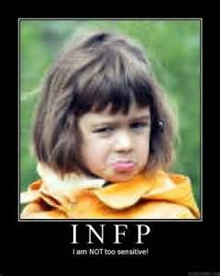 



The drunk, however, seemed **quite sure of himself**. （可这醉汉像是很有把握似的）

·**be/ feel sure of oneself 表示“有自信心”。**

he **clumsily** stepped aside to let it pass. （他踉跄地住旁边一闪，）

·**clumsily ['klʌmzili] adv. 笨拙地**，形状难看地。

The crowd **broke into cheers** and the drunk bowed. （牛扑空了，醉汉向人们鞠躬致谢）

·**break into** 的含义之一是**“突然发出／做出”、“突然……起来”，有控制不住的含义**。

·**cheer** [tʃiə] **v.喝彩;鼓励;鼓舞**。

·bow vi.,vt.鞠躬，欠身，低下（头等）。



Even the bull seemed to feel sorry for him, for it **looked on** **sympathetically** until the drunk was **out of the way** before once more turning its attention to the matador. （好像连牛也在为他感到遗憾，因为它一直同情地看着醉汉，直到他的背影消逝，才重新将注意力转向斗牛士）

·**look on可以表示“观看”、“旁观”**。

·sympathetically adv. 同情地。

·**out of the way**为固定短语，可以表示**“不挡道”、“不碍事”**。

71.

If **the Houses of Parliament** had not been **burned down** in 1834, the great clock would never have been **erected**. （如果不是**国会大厦**在1834年被焚毁的话，这座大钟永远也不会建造）

·parliament n. 议会，国会。

·**erect v. 建起，使竖立。**

·**the Houses of Parliament,国会大厦。**由于英国议会是由上议院（House of Lords）和下议院（House of Commons）组成的，所以Houses为复数形式。

**Big Ben** takes its name from Sir Benjamin Hall who was **responsible for** the making of the clock when the new Houses of Parliament were being built. （“大本”钟得名于本杰明.霍尔爵士，因为当建造新的国会大厦时，他负责建造大钟）

·**responsible for表示“对……需负责任／承担责任的”。**Who is responslble for the accident? 谁应对这起事故负责？

·-ing形式前面无冠词时，可直接跟宾语：**making the clock**。

-ing 前有冠词时，则其后不能直接跟宾语，而必须用of; **the making of the clock**.



It **is** not only **of** immense size, but is **extremely accurate** as well. （此钟不仅外型巨大，而且走时也非常准确）

·**accurate adj. 准确的。**

·**be of…表示人或物的特征。**



Officials from **Greenwich Observatory** have the clock checked twice a day. （格林尼治天文台的官员们每天两次派人矫正此钟）

·official n. 官员，行政人员。

·Greenwich n. 格林尼治。

·observatory n. **天文台**。



Once, however, it failed to give the correct time.（然而有一次，它却把时间报错）

A painter who had been working on the tower hung **a pot of** paint on one of the hands and slowed it down! （在钟塔上干活的一位油漆工把一只油漆桶挂在了一根指针上，把钟弄慢了！）

·**pot n.罐, 壶**。

72.

The great **racing driver**, Sir Malcolm Campbell, was **the first** man （to drive at over 300 miles per hour）. （杰出的**赛车选手**）

·**racing n. 竞赛**。

·per表示“每一”、“每”，通常用于商业及技术用语，**日常用语大多用 a/an**。 You can stay at the hotel at￡ 10 **per person per night**. 你们可以**每人每晚**花10英镑住在这家旅馆。

·**to引导的不定式短语为 the first man的定语。这种句型的词语有the second, the next/the last**以及**表示最高级的如 the best, the most intelligent等。**这些词语后面可以：  
→接名词或one（s），也可以不接：

She's always **the first** （to arrive） and **the last** （to leave）. 她总是第一个来到，最后一个离开。  
You're **the best** person （to advise me about buying a house）. 你是我买房子的最好顾问。  
→**the only后必须接一个名词或 one（s）**：  
You're **the only pereson/one** （to complain）.　你是惟一抱怨的人。



It was over 30 feet **in length** and had a 2,500-horsepower engine. （它的车身长30英尺，有一个2,500 马力的发动机）

he **had great difficulty in** controll**ing** the car because **a tyre burst** during the first run. （他很难把汽车控制住，因为在开始的行程中**爆了一只轮胎**）

·**burst** [bə:st] **v. 爆裂**。

·difficulty 表示“难”、“困难”时为不可数名词。表示**做某事有困难**时可以用 **have difficulty(in)doing sth. 结构， in通常可省略。**



73.

The **record-holder**（纪录保持者）

·**record-holder 纪录保持者**

Children who **play truant from school** are **unimaginative**. （逃学的孩子们都缺乏想像力）

·truant n. 逃学的孩子。**play truant from school表示“逃学”，**上下文清楚时也可以省略 from school,直接说 **play truant.** truant也可以单用，表示“逃学者”。

·**un-imagi-native [ʌn-im'æ-dʒə-nətiv] adj. 缺乏想像力的**。

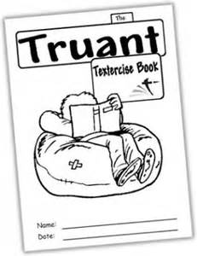

eight hours in a cinema seeing the same film **over and over again**, is usually **as far as they get**. （在电影院里坐上8个小时，一遍遍地看同一部电影）

·**over and over again**为固定短语，表示**“一再地”、“反复许多次地”**。

·as far as在这里表示“**到…程度**”、“就…而言”，是连词，与距离没有关系：As for as I know, his operation is successful. 就我所知，他的手术是成功的。

They have all been **put to shame** by a boy. （有那么一个小男孩，使上述所有逃学的孩子们都相形见绌了）

·shame n. 惭愧，羞耻。**put…to shame,使……蒙羞，使……相形见绌。**

What he has done **put his parents to shame**.他的所作所为**使他的父母感到羞耻**。



He **hitchhiked to** Dover. （他搭便车到了丹佛）

·hitchhike ['hitʃ.haik] v. **搭便车旅行**。

he hitchhiked to Paris in a **lorry**. （他又搭上卡车到了巴黎）

·lorry n. **卡车**。



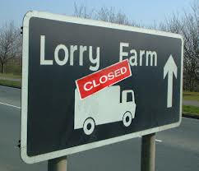

No one noticed the boy as he **crept off**. （当男孩从船里**爬出来（爬离）**时，谁也没有发现他）

·creep vi. 爬行，匐匍，（像爬行似地）慢慢前进；悄悄地／蹑手蹑脚地走；渐渐产生／出现。

The next car the boy stopped did not take him into the centre of Paris as he hoped it would, but to Perpignan **on the** French-Spanish **border**. （男孩截住的下一辆车，没有像他希望的那样把他带到巴黎市中心，而是把他带到了法国和西班牙边界上的佩皮尼昂）

·**border n. 边界**。

There he was **picked up** by a policeman and sent back to England by **the local authorities**. （他在那儿被一个警察抓住了，之后被**当局**送回了英国）

·**Pick up**的含义之一是**“逮捕”、“拘捕”**。

He has surely **set up a record** for the thousands of children who dream of **evading school**.（他无疑为成千上万梦想逃避上学的孩子们创造了一项纪录）

·**evade** [i'veid] **v. ①（巧妙地）逃脱，躲开。**

She **evaded a blow** from the man and then called out for help. 她**躲开了**那人的**一拳**，然后便大声呼救。

**②回避，逃避（尤指不当地）**：  
He always tries to **evade paying taxes**.他总是试图**逃税**。  
Many children dream of **evad**ing **school**.许多孩子梦想**逃避上学**。



74.

Out of the **limelight**

（舞台之外）

·**limelight n. 舞台灯光。l**imelight的原义为舞台照明用的“石灰光”，其引申意义为“众人注目的中心”。

An **ancient bus** stopped by a dry river bed and a party of famous actors and actresses got off. （一辆古旧的汽车停在一条干涸的河床边，一群著名男女演员下了车）

·ancient在这里表示“**老式的”、“古旧的**”，与old意思相近，但**比old有幽默感**。Where did you find that **ancient dress**? 你在哪里找到这件**老掉牙的衣服**？



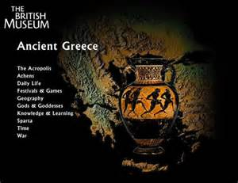

they had **taken special precautions** so that no one should recognize them. （他们特别小心以防别人认出他们）

·**precaution** [pri'kɔ:ʃən] **n. 预防措施；避孕措施**；预防，防备，警惕。I had **taken the precaution of doing** a little research before I left London.我已在离开伦敦前**进行了预防准备**，做了些调查研究。

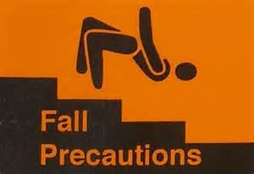

But as they soon discovered, **disguises** can sometimes be too perfect. （但他们很快就发觉，化装的效果有时过分完美了）

·**disguise** [dis'gaiz] **vt.掩饰, 假装,假扮**；n.伪装, 伪装物。



**This is a wonderful place** for a picnic,（在这个地方野餐简直太妙了）

'**It couldn't be better**, Gloria,' Brinksley Meers agreed. 'No newspaper men, no film fans! Why don't we **come more often**?'

（“**是再好不过的了**，格格利亚。”布林克斯利.米尔斯表示同意，“没有记者，没有影迷！我们为什么不**经常来**这里呢？”）

two other actors, had carried two large food baskets to a **shady spot** under some trees. （另外两位演员，已经把两个大食品篮子提到了一片树荫下）

·**shady** ['ʃeidi] **adj.** **遮荫的**。

'Now you **get out of here**, all of you!' he shouted. （“你们都从这里走开，全都走开！”他大叫着）

·**get out of here是语气较重的说话方式，表示“滚出去”、“滚开”。** Now you get out of here fast!（现在你们赶快滚吧！）

'I'm **sheriff** here. Do you see that notice? It says "No Camping" -- **in case** you can't read!' （“我是这里的司法长官。你们看到那个布告牌了吗？上面写着‘禁止野营’－－除非你们不识字！”）

·**she-riff ['ʃe-rif] n.** **司法长官**。

·**in case表示“假使”、“万一…的话”、“免得”、“以防万一”。**它通常用于引导“条件”或“目的状语从句”。**当句子表示“将来的时间”时，in case后面必须用“现在时态”或should/might**:

I'm taking a raincoat with me **in case I need it**.我随身带着雨衣，**以备不时之需**。（表示目的）  
**In case he comes**/should come, give him this letter.**假如／万一他来的话**，把这封信给他。（表示条件）



don't **be** too **hard on us**. （别使我们难堪。）

·**be bard on表“对…（过分）严厉”。**

'Oh, is it?' said the sheriff with a **sneer**. （“噢，是吗？”那位司法长官冷笑一声说道）

·sneer [sniə] n. 冷笑。

75.

When **a light passenger plane** **flew off course** some time ago, it crashed in the mountains and its **pilot** was killed. （不久前，一架轻型客机偏离了航线，在山区坠毁，飞行员丧生）

·passenger n.乘客, 旅客。

·**flew off course,飞离航线。off表示“偏离”**，为介词：Our office is **off** the main street.我们的办公室不靠大街。

·pilot n.**飞行员**, 领航员。

It was **the middle of winter**. Snow **lay thick** on the ground. （此时正值隆冬季节，地上积着厚厚的雪）

·thick adj. **厚的**。

·**lie表示“处于某种状态”时，后面常跟形容词或分词**：When I saw her yesterday, she **lay ill** in bed.昨天我见到她时，她正**卧病**在床。

she turned a **suitcase** into a bed and put the children inside it, covering them with all the clothes she could find. （她把**提箱**当作小床，把两个孩子放了进去，又把所有能找到的衣服都盖在了孩子们身上）



During the night, it got **terribly** cold. （夜里，天冷得厉害）

·terribly ['terəbəli]adv.**可怕地**, <口>非常地,很。

·**get在口语中使用较多，表示“成为（某种状态）”。** It's getting warmer and warmer.天气越来越暖和了。

The woman **kept** as near as she could to the children and even tried to get into the case herself, （这位妇女尽可能地靠近孩子，甚至自己也想钻进箱子里去，）

·**keep在这里表示“保持（某种状态）**”。

·**as…as one can/could和 as…as possible同义，都表示“尽可能…”：**He got through as much food as he could and set out. 他吃了尽可能多的食物，然后出发了。

she heard planes passing overhead and wondered how she could **send a signal**. （她听到头顶上有飞机飞过，但不知道怎样才能发个信号）

·**signal n.** **信号**。



She **stamped out** the letters 'SOS' in the snow. （她在雪地上**踩出**了“SOS”这3个字母）

·**stamp v. 跺，踩。**

**It was not long before** a helicopter arrived on the **scene** to rescue the **survivors** of the plane crash. （不久，一架直升飞机飞抵飞机失事现场，来搭救这几个幸存者）

·helicopter ['helikɔptə] n. 直升飞机。

·**scene** [si:n] n. **现场**。

·**survivor** [sə'vaivə] n. **幸存者**。

·**It was not long before…**为固定句型，表示**“不久就……”**（**也可以用 It will not be long before…表示将来可能发生的事）**，其含义与before long（不久）相近，只是before在课文这个句型中是连词，而在before long中为介词：  
It was not long before they learnt the news. 他们不久就知道了这消息。  
It will not be long before he gets over his illness. 他大概不久就会痊愈。

76.

**April Fools' Day 四月愚人节**

To end our **special news bulletin**,' said the voice of the television **announcer**, （“作为我们**专题新闻节目**的结尾，”电视广播员说，）

·**bulletin** ['bulətin] n. **新闻简报**。

·**announcer** n. （电视、电台）**播音员**。

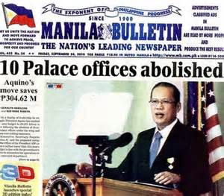

we're **go**ing **over** to the **macaroni** fields of Calabria. （我们现在到克拉布利亚的通心粉田里。）

·**go over表示“往……走过去”，暗示中间原有一段距离**。

·**macaroni** [.mækə'rəuni] n. 通心面，**空心面条。是加工过的面粉**。它不可能像wheat, rice一样长在田里，不该与fields连用，但由于是愚弄人的玩笑，所以这篇文章通篇都是以通心粉长在地里为前提进行的描述。由于macaroni是意大利语，很可能有人会以为是某种没听说过的新的粮食品种。

Two of **the leading growers**, tell me that they have been expecting a **splendid crop** this year and **harvesting** has begun earlier than usual. （两个**主要种植者**，告诉我，他们一直期待着今年获得一个**大丰收**，收割工作比往年开始要早些）

·**splendid** ['splendid] adj. **极好的，辉煌的**。

·**crop n.农作物, 收成**, 庄稼, (一)批。

·**harvesting n. 收获, 收割**。动词harvest的现在分词形式。



between them, have just finished cutting three **cartload**s of golden brown macaroni **stalk**s. （他们协力割下了3车金黄色的通心粉秸）

·**between them,由于他们共同努力的结果。between作介词时含义之一是“作为…共同努力的结果”、“协力”。** **Between us** we pulled down the tree.**我们协力**把树拉倒了。

·**cartload n. 一车的载量**, 大量。

·**stalk n. 茎,梗**。

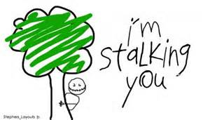

The whole village has been working day and night gathering and **thresh**ing this year's crop before **the September rains**. （全村的人都日夜奋战，要赶在9月的雨季之前把今年的庄稼收获上来，打完场）

·**thresh v. 打（庄稼）**。

·**the September rains,9月雨季。**当rain指“雨季”、“季节性的雨”，尤其是**热带地区的雨季时，要用复数形式。**

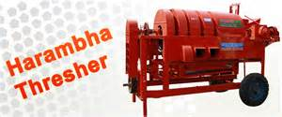

Mrs. Brabante is talking to the manager of the local factory where the crop is **process**ed. （布拉班特太太现在正和负责通心粉加工的当地加工厂的经理交谈）

·process ['prɑ:ses] v. **加工**。

This last **scene** shows you what will happen at the end of the harvest: the famous Calabrian macaroni-eating competition! （这最后一个镜头向您展示了收获之后将发生的事情：著名的克拉布利亚人吃通心粉大赛！）

·harvest n.收成, 收获, 收割, 成果, 后果。

**Signor** Fratelli, the present champion, has won it every year since 1991. （目前的冠军弗拉特里先生，自1991年以来，年年获胜）

·Signor ['si:njəur] n.（意大利语）**先生**。

·present adj. 目前的。

·champion ['tʃæmpiən] n. 冠军。

And that ends our special bulletin for today, Thursday, April lst. We're now going back to the **studio**.' （今天——4月1日，星期四——的专题新闻节目到此结束。现在我们回到电视演播室。）

·bulletin ['bulətin] n. 新闻简报。

·studio n. **播音室**。

77.

The mummy is **that of** Shepenmut who was once a singer in the Temple of Thebes. （这是曾在底比斯神殿里当过歌手的赛潘姆特的木乃伊）

·**mummy** ['mʌmi] n. **木乃伊**。

·temple n. 庙。

·**that用以指代前面的 the mummy**，以避免重复。在指代特指的事物时，尤其是在比较状语从句中，常用that和those指代前面提到的事物。**that of和those of一般用于较正式的文体中**：The area of the USA is larger than that of Britain.（这里that of指代area面积） 美国的面积比英国的大。



As there were strange **marks** on the **X-ray plates** taken of the mummy, （由于在给这个木乃伊拍摄的X光片子上有点奇怪的斑点）

·mark n. 斑点。

·Plate [pleit] n. （照相）底片。

The operation, which lasted for over four hours, **proved** to be very difficult because of the **hard resin** which covered the skin. （手术持续了4个多小时，非常难做，因为皮肤上覆盖着一层**硬硬的树脂**）

·**prove v. 显示出**。

·**resin** ['rezin] n. **树脂**。

·skin n. 皮肤。



The doctors removed a **section** of the mummy and sent it to a laboratory. （医生们从木乃伊身上取下一个切片，送去化验）

·**section n. 切片**。

·laboratory ['læbrə'tɔri] n.实验室。

a small **wax figure** of the god Duamutef. （一个蜡制的杜瓦木特夫神小塑像）

·wax vt.(用蜡)涂。

·figure n. （人的）体形；人像。



The doctors **have not yet decided** how the woman died. （医生们至今还未确定这位妇女的死因）

·**decide**在这里**不是指**“下决心／决定”，**而是指“对…下判决”、解决（悬案）**”等：The police **cannot decide yet** which of the two men is guilty.　警方尚不能确定这两人中哪一个有罪。

They **fear**ed that the mummy would **fall to pieces** when they cut it open, （他们曾担心在把木乃伊切开后，它会散成碎片）

·fear v.害怕, 担心。

·**fall to pieces,散掉，成为碎片**（也可以说**go to pieces**）。

The mummy successfully **survived** the operation. （这具木乃伊成功地经受了这次手术）

·survive v. 幸免于。survive表示“经历（灾难等）之后还活着”。

78.

After reading an article **entitled** '**Cigarette Smoking** and Your Health' I **lit a cigarette** to **calm my nerves**. （读完一篇题为《吸烟与健康》的文章之后，我点上了一枝香烟，来镇定一下自己紧张的神经）

·entitle v. 以……为名，题名。

·**Cigarette Smoking吸烟。**

·Lit：light的过去式和过去分词形式，vi.点燃;发光,发亮。

·calm [kɑ:m]v. **使镇定**。

·nerve [nə:v]n. **神经**。

I smoked with **concentration** and pleasure（我聚精会神而又愉快地吸着这枝烟）

·concentration [.kɔnsen'treiʃən] n. **集中，专心**。全神贯注；专注：Neal kept interrupting, breaking my concentration. 尼尔不停地打断我，使得我无法集中注意力。

·pleasure n.愉快, 高兴, 快事。



my wife **suffered terribly**.

·suffer v. 受苦，受害。

·Terribly

adv.可怕地, <口>非常地,很（我妻子吃尽了苦头）

I had all the usual **symptoms** of someone giving up smoking: **a bad temper** and **an enormous appetite**. （我具备了戒烟者通常表现出来的所有症状：脾气暴躁和食欲旺盛）

·symptom ['simptəm]n. **症状**。

·temper n. 脾气。

·Enormous adj.**巨大的, 庞大的**。

·appetite ['æpə.tait]n. **胃口，食欲**。

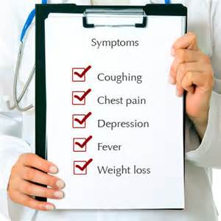

They **made no effort** to hide their amusement whenever I **produced** a packet of sweets from my pocket. （每当我从口袋里掏出一包糖果时，他们都毫不掩饰地表现出他们对此感到非常好笑）

·**make no effort表示“根本不作努力”。** Georeg **made every effort** to get/at getting the job. 乔治**竭尽全力**想得到那份工作。

·produce v. **拿出**。

When my old friend Brian **urged** me to accept a cigarette, it was more than I could bear. （当我的老朋友布赖恩极力劝我接受一枝香烟时，我再也忍不住了）

·urge [ə:dʒ]v. **力劝，怂恿**；n.冲动, 强烈愿望。

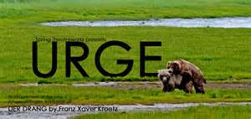

I took one **guiltily**, lit it and smoked with **satisfaction**. （我**内疚地**接过一枝点上，心满意足地抽起来）

·satisfaction n. **满意，满足**。

My wife was **delighted** that things had **returned to normal** once more. （一切又都**恢复了正常**，为此我妻子十分高兴）

·delighted adj. **欣喜的，**高兴的, 快乐的。



79.

A **flight attendant** would **take charge of** me and I never had an unpleasant experience. （我总是由一位空中乘务员照管，从未遇到过不愉快的经历）

·attendant [ə'tendənt]adj.伴随的 n.服务员, 侍从。**flight attendant 空中乘务员。**

·**would表示过去经常发生的事。**

·**take charge(of) 表示“接管”、“开始管理”等**：

She **took charge of the child** after his parents died.孩子的父母去世后，她**接管了那孩子**。

The new manager will **take charge (of the company)** from next week.新经理从下星期开始**管理公司**。



I am used to travelling by air and **only** on one occasion **have I** ever **felt frightened**. （我习惯了乘飞机旅行，只是有一次把我吓坏了）

·frightened adj. 害怕，担惊。

·**这是一个倒装句，它通常用来加强语气。**用倒装句的情况包括：  
（1）**句首为否定或近似否定的副词(never, rarely, little, on no occasion, hardly, no sooner…than等)：  
Never has he** got so many letters.　他从未收到过这么多信。  
**Little does he** realize how important this meeting is.　他对这个会议的重要性知之甚少。

**No sooner had he** returned than he bought a house and went to live there.　他刚一回来便买下了一幢房子住了进去。

（2）句**首为only构成的词组（如 only after, only then等）：**  
**Only then did I** realize what a mistake I have made.　只是到了那时我才意识到我犯了个什么错误。

**Only** after she had taken off her coat and hat **could I** recognize her.　只有在她脱掉大衣和摘下帽子以后我才认出了她。

After **taking off**, we were flying low over the city and slowly **gaining height**, （起飞之后，我们在城市上空低低地飞行，然后慢慢爬高）

·**take off 脱掉；起飞；（使）离开。**

·**gain height,（飞机）增加高度，爬高。**gain在这里为及物动词，表示“增加”。

a **flight attendant** told us to **keep calm** and to **get off the plane** quietly as soon as it had **touched down**. （一位空中乘务员告诉我们要**保持镇静**，待飞机一着陆，就马上不声不响地离开飞机）

·calm[kɑ:m] **adj.镇定的；平静的**。

·**get off 下（车、马等）；离开；发出。**

·**touch down,（飞机）着陆，降落。**

Everybody on board was worried and we were **curious** to find out what had happened. （飞机上的人都很着急，大家都急于想知道究竟出了什么事）

·**curious adj. 急于了解，好奇的**。



The police had been told that a bomb had been **plant**ed on the plane. （有人报告警察，说飞机上安放了一枚炸弹）

·plant v. **安放，**放置，安置；布置。On that day many policemen were **planted** along the main street.　那天（城里的）主要街道上**部署**了许多警察。

After we had landed, the plane was searched thoroughly. Fortunately, （我们降落之后，飞机被彻底搜查了一遍）